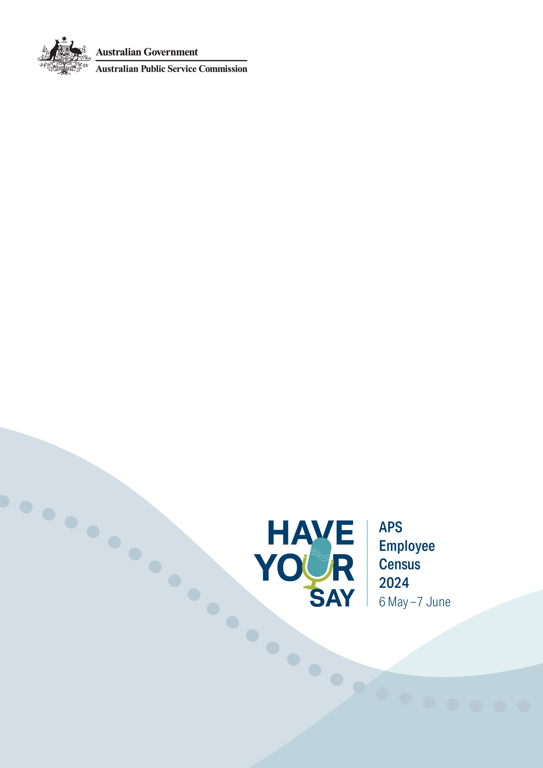

Responding to APS Employee Census bullying and harassment results

The APS Employee Census has an underlying framework that identifies and considers conditions within workplaces that influence employee and workgroup performance.

This guide explores one element of this framework, bullying and harassment, and outlines:

* What bullying and harassment is
* Its effects
* The specific questions that measure bullying and harassment
* Workplace bullying and harassment responsibilities
* Resources available to employees and managers

**Bullying and harassment**

Workplace bullying and harassment are unacceptable behaviours not tolerated in the APS. All Australian Public Service employees are required to behave in accordance with the APS Values and Code of Conduct, under the *Public Sector Act 1999*.

The APS Code of Conduct makes it clear that, in their workplace, all APS employees must treat everyone with respect and courtesy, and without harassment.

The APS Employee Census and the APS Agency Survey provide indicators of how well the Values and Code of Conduct are being upheld across the service. Any APS Employee Census result that reflects perceptions of bullying and harassment in the workplace should prompt actions that address unacceptable behaviour.

**Bullying:**A worker is bullied at work if, while at work, an individual or group of individuals repeatedly behaves unreasonably towards the worker, or group of workers of which the worker is a member, and that behaviour creates a risk to health and safety. To avoid doubt, this does not apply to reasonable management action carried out in a reasonable way.

**Harassment:** Workplace harassment entails offensive, belittling or threatening behaviour directed at an individual or group. The behaviour is unwelcome, unsolicited, usually unreciprocated and usually, but not always, repeated. Reasonable management action carried out in a reasonable way is not workplace harassment.

## Effects of bullying and harassment

Workplace bullying and harassment pose risks to Work Health and Safety because they affect the mental and physical health of workers. They can be harmful both to the person experiencing, and to those who witness them. The effects will vary and may include:

* distress, anxiety, panic attacks or sleep disturbance
* physical illness such as headaches, fatigue, digestive problems and muscular tension
* negative impacts on work performance, concentration and ability to make decisions
* loss of self-esteem and feelings of isolation
* deteriorating relationships with colleagues, family and friends
* depression
* thoughts of suicide

Workplace bullying and harassment also have negative impacts on organisations and lead to:

* high staff turnover and associated recruitment and training costs
* increased absenteeism
* lost productivity
* disruption to work when complaints are being investigated
* costs for counselling, mediation and support
* costly workers compensation claims or legal action

## APS Employee Census measures of bullying and harassment

APS Employee Census respondents were asked the following questions to better understand their perceptions of harassment and bullying:

* During the last 12 months, have you been subjected to harassment or bullying in your current workplace?
* What type of harassment or bullying did you experience?
* Who was responsible for the harassment or bullying?
* Did you report the harassment or bullying?
* Please explain why you chose not to report the harassment of bullying?

## Actions to improve scores on these questions

Demonstrated senior management commitment in identifying, preventing and responding to workplace bullying is one of the key factors for preventing unreasonable behaviour and managing psychological risks.

Effective leaders model their organisation’s values and standards for workplace behaviour through their own conduct. This sends a clear message to workers that the organisation is serious about preventing workplace bullying and contribute to a positive workplace culture where unacceptable behaviours are not tolerated.

Managers can demonstrate their commitment to safe workplaces in various ways including:

* Modelling respectful behaviours at all times
* Developing and implementing a bullying policy which clearly identifies the expected behaviours and consequences of not complying
* Dealing with unreasonable behaviour as soon as they become aware of it
* Ensuring that reports of bullying are taken seriously and properly investigated, and
* Consulting with workers.

For more detailed information, please see pages 13-21 of [Safe Work Australia’s guide for preventing and responding to workplace bullying](https://www.safeworkaustralia.gov.au/system/files/documents/1702/guide-preventing-responding-workplace-bullying.pdf).

## Workplace responsibilities

Under Work Health and Safety laws, a person conducting a business or undertaking must ensure, so far as reasonably practicable that workers and other persons are not exposed to psychological or physical risks in the workplace. According to the Model Code of Practice: Managing psychosocial hazards at work, there are 14 psychosocial hazards that can have the potential to cause psychological or physical harm. Two of these hazards are bullying and harassment.

## Respect at work

In December 2022, the Anti-Discrimination and Human Rights Legislation Amendment (Respect at Work) Act 2022 came into effect. Under this Act, employers now have **a positive duty**, which means employers must proactively take reasonable and proportionate measures to eliminate sex discrimination, sexual and sex-based harassment, hostile work environments and victimisation. This Act also confers new compliance and enforcement functions on the Australian Human Rights Commission. This means that the Australian Human Rights Commission can initiate action under its new compliance and enforcement powers if they suspect an employer is not meeting this threshold.

This legislation can be viewed here: [Anti-Discrimination and Human Rights Legislation Amendment (Respect at Work) Act 2022](https://www.legislation.gov.au/Details/C2022A00085)

## Resources available to employees and managers

There are a variety of organisations within and outside of the APS that are able to provide expert, tailored and professional advice.

### **Your agency’s HR area:**

In the first instance, reach out to our agency’s HR area to discuss what agency specific supports your organisation has available. For instance, your agency likely has an employee assistance program (EAP) available to assist and support staff.

### **Comcare**

Comcare offers a range of resources and advice on bullying and harassment, among other psychosocial hazards.

*Resources:*

* [Bullying: Office Safety tool](https://www.comcare.gov.au/office-safety-tool/workplace-safety/bullying) | Comcare
  + [Two Minute Toolbox Talk to Team Leaders script | Comcare](https://www.comcare.gov.au/about/forms-pubs/docs/pubs/safety/two-minute-toolbox-talk-team-leaders.pdf)
* [Harassment including sexual harassment | Comcare](https://www.comcare.gov.au/safe-healthy-work/prevent-harm/psychosocial-hazards/harassment)
  + [Workplace sexual harassment: Practical guidance for workers](https://www.comcare.gov.au/about/forms-pubs/docs/pubs/safety/workplace-sexual-harassment-guidance-for-workers.pdf)
  + [Workplace sexual harassment: Practical guidance for managers and supervisors](https://www.comcare.gov.au/about/forms-pubs/docs/pubs/safety/workplace-sexual-harassment-guidance-for-managers-and-supervisors.pdf)
  + [Workplace sexual harassment: Practical guidance for employers](https://www.comcare.gov.au/about/forms-pubs/docs/pubs/safety/workplace-sexual-harassment-guidance-for-employers.pdf)
  + [Workplace sexual harassment: Regulatory guidance for employers on their work health and safety responsibilities](https://www.comcare.gov.au/about/forms-pubs/docs/pubs/safety/workplace-sexual-harassment-regulatory-guidance-for-employers-on-whs-responsibilities.pdf)

*Training:*

* Workshop: Bullying – Awareness and prevention
* Workshop: Psychological risk management
* Microlearn: How to prevent workplace sexual harassment
* eLearn: Implementing and monitoring early intervention programs in the workplace
* For more information about the training offered by Comcare, and for access to the training, see this link: [Training list by topic | Comcare](https://www.comcare.gov.au/about/training/training-list-by-topic)

### **Fair Work Commission**

The Fair Work Commission offers a range of information regarding bullying and sexual harassment at work:

* [Bullying | Fair Work Commission](https://www.fwc.gov.au/issues-we-help/bullying)
* [Sexual harassment | Fair Work Commission](https://www.fwc.gov.au/issues-we-help/sexual-harassment)

As well as assistance to resolve workplace bullying:

* [The process to resolve workplace bullying | Fair Work Commission](https://www.fwc.gov.au/issues-we-help/bullying/process-resolve-workplace-bullying)

### **Safe Work Australia**

Safe Work Australia offers a range of resources addressing bullying, approaching it in a range of different ways:

* [Dealing with workplace bullying - a worker's guide | Safe Work Australia](https://www.safeworkaustralia.gov.au/doc/dealing-workplace-bullying-workers-guide)
* [Bullying - Resources | Safe Work Australia](https://www.safeworkaustralia.gov.au/safety-topic/hazards/bullying/resources)

As well as a guide to assist in the prevention and response to bullying:

* [Guide for preventing and responding to workplace bullying | Safe Work Australia](https://www.safeworkaustralia.gov.au/doc/guide-preventing-and-responding-workplace-bullying)
* This resource also provides further information about other state, territory, and federal regulators, agencies, and support services.

### **Australian Human Rights Commission**

Employees can make a complaint to the Australian Human Rights Commission if they have experienced discrimination, harassment and bullying based on their:

* [Sex, including pregnancy, marital or relationship status including same-sex and de facto status, breastfeeding, family responsibilities, sexual harassment, gender identity, intersex status and sexual orientation](https://humanrights.gov.au/complaints/complaint-guides/information-people-making-complaints/complaints-under-sex-discrimination-act)
* [Disability, including temporary and permanent disabilities; physical, intellectual, sensory, psychiatric disabilities, diseases or illnesses; medical conditions; work related injuries; past, present and future disabilities; and association with a person with a disability](https://humanrights.gov.au/complaints/complaint-guides/complaints-under-disability-discrimination-act)
* [Race, including colour, descent, national or ethnic origin, immigrant status and racial hatred](https://humanrights.gov.au/our-work/complaint-information-service/complaints-under-racial-discrimination-act)
* [Age, covering young people and older people](https://humanrights.gov.au/our-work/complaint-information-service/complaints-under-age-discrimination-act)
* [Sexual preference, criminal record, trade union activity, political opinion, religion or social origin (in employment only)](https://humanrights.gov.au/our-work/complaint-information-service/information-people-making-complaints-0)

The AHRC has a helpful harassment and bullying fact sheet:

* [Workplace bullying: Violence, Harassment and Bullying Fact sheet | Australian Human Rights Commission](https://humanrights.gov.au/our-work/employers/workplace-bullying-violence-harassment-and-bullying-fact-sheet)

The AHRC also have information specifically targeting sexual harassment:

* [Ending workplace sexual harassment: A resource for small, medium and large employers | Australian Human Rights Commission](https://humanrights.gov.au/our-work/sex-discrimination/publications/ending-workplace-sexual-harassment-resource-small-medium?_ga=2.136771824.1992097580.1629949059-641548023.1626312841)

The AHRC also offer a range of different training options for staff:

* [Discrimination, bullying, and harassment prevention training | Australian Human Rights Commission](https://humanrights.gov.au/education/training/training-topic/discrimination-bullying-and-harassment-prevention-training)
* [Sexual harassment prevention training | Australian Human Rights Commission](https://humanrights.gov.au/education/training/training-topic/sexual-harassment-prevention-training)
* [Anti-racism training | Australian Human Rights Commission](https://humanrights.gov.au/education/training/training-topic/anti-racism-training)

For more information about the training offered by Australian Human Rights Commission, and for access to the training:

* [Training by topic | Australian Human Rights Commission](https://humanrights.gov.au/education/training/training-topic)

### **Respect@Work**

Respect@Work have developed the Good Practice Indicators Framework for preventing and responding to workplace sexual harassment – it contains intended outcomes and indicators of good practice for employers with respect to preventing and responding to sexual harassment.

* [Good Practice Indicators Framework for Preventing and Responding to Workplace Sexual Harassment | Respect at Work](https://www.respectatwork.gov.au/sites/default/files/2022-12/Attachment%20B%20-%20Good%20Practice%20Indicators%20Framework%20for%20Preventing%20and%20Responding%20to%20Workplace%20Sexual.pdf)

### **Beyond Blue**

This resource mentions bullying, harassment and sexual harassment. If you find this content challenging, please seek support.

For free, confidential 24/7 counselling [contact the Beyond Blue Support Service online](https://www.beyondblue.org.au/get-support/talk-to-a-counsellor) or call on 1300 224 636.

This resource is designed to provide high level advice and guidance towards sources of support. It will be updated as new sources of support emerge.